Robust clipped correlation: EURUSD and USDCAD
Method 04 / daily log returns clipped at ±0.01, ±0.02, ±0.03 / Alpari D1 full available history

Study setup
Logical pair: EURUSD , USDCAD
Broker symbols: EURUSD_i , USDCAD_i
Snapshot: 2026-11-03_majors_alpari_D1
Timeframe: D1
Matched return window: 1999-01-05 to 2026-11-02 (UTC bar dates)
Matched return count n: 7188
Dropped unfinished last bar dated 2026-11-03 UTC after a tick-volume check against the prior complete day.
Clip bounds c in log-return units: 0.01, 0.02, 0.03 (about ±1%, ±2%, ±3% on the log scale). Headline c = 0.02.
Clipping caps a day's magnitude at ±c and keeps the row; it does not drop the day, so n is the same at every c.
Complete matched rows (Excel): EURUSD-USDCAD_Clipped_D1.xlsx
Complete matched rows (HTML table): EURUSD-USDCAD_Clipped_D1_data.html

Method carried forward
Each matched daily log return of close, ln(close_t / close_t-1), is clipped in the broker quote direction before Pearson correlation: x_tilde = min(c, max(-c, x)) and y_tilde = min(c, max(-c, y)), then rho_clip = Pearson(x_tilde, y_tilde) on the same rows as raw Pearson r. Quotes are not inverted. A day beyond ±c stays in the sample at the cap; n does not change. rho_clip is symmetric under swap of the two symbols. rho_clip = 0 means no straight-line link among the clipped values in this sample; it does not mean no link of any kind. The score is not a cause, not a lead, and not a trading signal. Daily rows are not independent draws, so the two-sided p-value and Fisher interval are reported and treated as secondary to rho_clip. Cap-hit counts (|log return| > c) flag how much of each leg was capped.

Raw Pearson on the same rows
Pearson r: -0.456626
Two-sided p-value: 0
Approximate 95% Fisher interval: [-0.474732, -0.438132]
This is the unclipped comparison required by the method. The headline score is rho_clip at c = 0.02 below.

Clipped results
n = 7188 at every c. Headline row is c = 0.02. Cap-hit count is the number of days with |log return| > c before clipping.
c | rho_clip | p | ci_low | ci_high | rho_minus_r | EURUSD_cap_hits | USDCAD_cap_hits | EURUSD_cap_share | USDCAD_cap_share
0.01 | -0.440091 | 0 | -0.45854358 | -0.42125808 | 0.016535017 | 621 | 403 | 0.086394 | 0.056066
0.02 | -0.453994 | 0 | -0.47215721 | -0.43544632 | 0.002631106 | 41 | 32 | 0.005704 | 0.004452
0.03 | -0.456864 | 0 | -0.47496577 | -0.43837568 | -0.00023843298 | 4 | 3 | 0.000556 | 0.000417

Conclusion
Over 7188 matched daily log-return rows for EURUSD and USDCAD (broker quote directions unchanged), headline robust clipped correlation at c=0.02 is -0.4540 (negative, moderate straight-line association among clipped values in this sample). Approximate 95% Fisher interval on the clipped series: [-0.4722, -0.4354]. Same-sample raw Pearson r is -0.4566 (rho_clip minus r = 0.0026). Sensitivity across the fixed grid: c=0.01 same sign; c=0.02 same sign; c=0.03 same sign. Two-sided p under the usual independent bivariate-normal model is 0; that model does not match linked daily FX returns, so treat p as secondary. This does not establish cause, lead-lag, or a lasting trading rule.

What to look at in this file next time
1) rho_clip at c = 0.02 versus raw Pearson r. 2) Whether c = 0.01 and c = 0.03 keep the same sign as 0.02. 3) Cap-hit counts before treating a large gap as settled. 4) The ±0.02 lines on the returns chart and the clip box on the scatter.

Charts
Daily closes

Daily log returns with +/- 0.02 clip lines
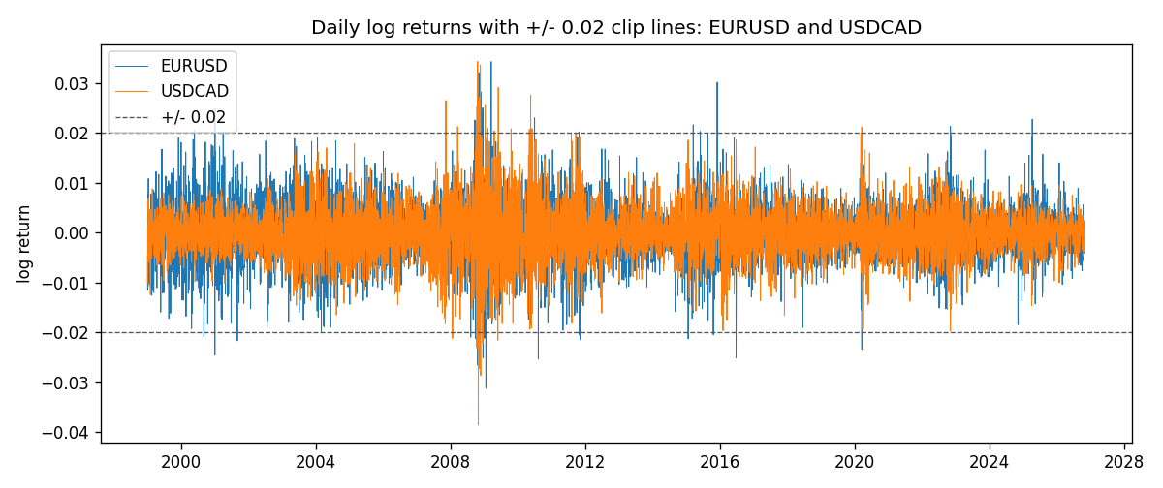
Log-return scatter with +/- 0.02 clip box
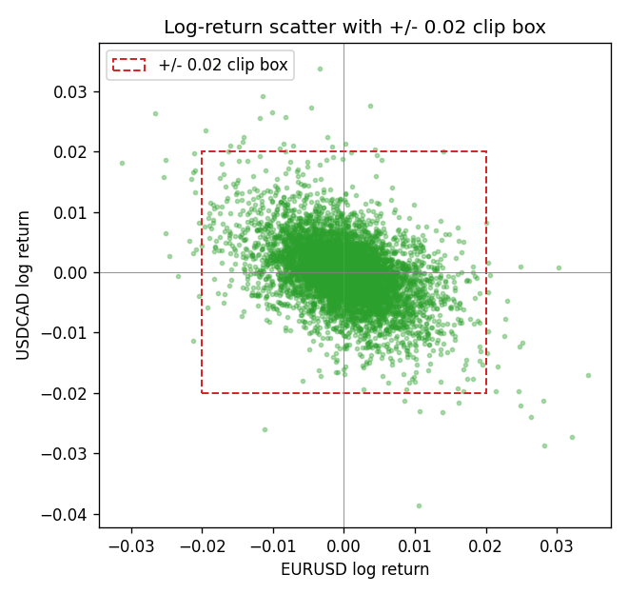

Data report
Every matched row that entered the clipped and raw correlations is stored in the sibling Excel workbook named EURUSD-USDCAD_Clipped_D1.xlsx. That file is the complete data archive for redrawing charts. Embedding all rows as a Word table is impractical at this length; the Word file holds the column list, column summaries, and the first and last 15 matched rows.
Columns: time, EURUSD_open, USDCAD_open, EURUSD_high, USDCAD_high, EURUSD_low, USDCAD_low, EURUSD_close, USDCAD_close, EURUSD_tick_volume, USDCAD_tick_volume, EURUSD_spread, USDCAD_spread, EURUSD_real_volume, USDCAD_real_volume, EURUSD_log_return, USDCAD_log_return, EURUSD_log_return_clip_0p01, USDCAD_log_return_clip_0p01, EURUSD_log_return_clip_0p02, USDCAD_log_return_clip_0p02, EURUSD_log_return_clip_0p03, USDCAD_log_return_clip_0p03
Column summaries (matched calculation rows)
column | count | mean | std | min | 25% | 50% | 75% | max
EURUSD_open | 7188 | 1.1814345 | 0.15078289 | 0.8272 | 1.086195 | 1.16617 | 1.2939425 | 1.5995
USDCAD_open | 7188 | 1.2667783 | 0.16890181 | 0.9168 | 1.1183975 | 1.298465 | 1.37211 | 1.6183
EURUSD_high | 7188 | 1.1865652 | 0.15138546 | 0.8326 | 1.0902775 | 1.17128 | 1.2993025 | 1.6038
USDCAD_high | 7188 | 1.2716763 | 0.16885945 | 0.9336 | 1.12285 | 1.30387 | 1.37649 | 1.619
EURUSD_low | 7188 | 1.1764236 | 0.15010221 | 0.8227 | 1.0820675 | 1.16257 | 1.2883725 | 1.5865
USDCAD_low | 7188 | 1.26222 | 0.16893673 | 0.9056 | 1.114065 | 1.293535 | 1.367805 | 1.6102
EURUSD_close | 7188 | 1.181473 | 0.1507571 | 0.8267 | 1.0860725 | 1.166175 | 1.2939575 | 1.5997
USDCAD_close | 7188 | 1.2667932 | 0.16887388 | 0.916 | 1.118295 | 1.29844 | 1.372365 | 1.6137
EURUSD_tick_volume | 7188 | 103177.84 | 173518.96 | 218 | 9407.75 | 52764 | 99553.25 | 1471626
USDCAD_tick_volume | 7188 | 81016.727 | 147303.02 | 37 | 5545 | 40941.5 | 71627 | 1410818
EURUSD_spread | 7188 | 19.349471 | 16.556644 | 0 | 8 | 12 | 30 | 50
USDCAD_spread | 7188 | 23.444073 | 18.266035 | 0 | 9 | 17 | 40 | 60
EURUSD_real_volume | 7188 | 4.031926e+10 | 1.6689501e+11 | 0 | 0 | 0 | 0 | 3.6149665e+12
USDCAD_real_volume | 7188 | 1.8376704e+10 | 9.6688094e+10 | 0 | 0 | 0 | 0 | 2.5751613e+12
EURUSD_log_return | 7188 | -7.59e-06 | 0.00580128 | -0.03123819 | -0.0032472 | 0 | 0.00325412 | 0.03433183
USDCAD_log_return | 7188 | -1.518e-05 | 0.00514306 | -0.03859748 | -0.00283637 | 4.741e-05 | 0.00272353 | 0.03436319
EURUSD_log_return_clip_0p01 | 7188 | -9.33e-06 | 0.00501091 | -0.01 | -0.0032472 | 0 | 0.00325412 | 0.01
USDCAD_log_return_clip_0p01 | 7188 | -3.482e-05 | 0.00449543 | -0.01 | -0.00283637 | 4.741e-05 | 0.00272353 | 0.01
EURUSD_log_return_clip_0p02 | 7188 | -1.364e-05 | 0.00571561 | -0.02 | -0.0032472 | 0 | 0.00325412 | 0.02
USDCAD_log_return_clip_0p02 | 7188 | -2.015e-05 | 0.00504345 | -0.02 | -0.00283637 | 4.741e-05 | 0.00272353 | 0.02
EURUSD_log_return_clip_0p03 | 7188 | -8.35e-06 | 0.0057953 | -0.03 | -0.0032472 | 0 | 0.00325412 | 0.03
USDCAD_log_return_clip_0p03 | 7188 | -1.51e-05 | 0.00512811 | -0.03 | -0.00283637 | 4.741e-05 | 0.00272353 | 0.03
First 15 matched rows (selected columns)
time | EURUSD_close | USDCAD_close | EURUSD_log_return | USDCAD_log_return | EURUSD_log_return_clip_0p02 | USDCAD_log_return_clip_0p02
1999-01-05 | 1.1758 | 1.5123 | -0.0048360507 | -0.010131666 | -0.0048360507 | -0.010131666
1999-01-06 | 1.1623 | 1.5118 | -0.011547966 | -0.0003306769 | -0.011547966 | -0.0003306769
1999-01-07 | 1.1712 | 1.5141 | 0.0076280636 | 0.0015202092 | 0.0076280636 | 0.0015202092
1999-01-08 | 1.1585 | 1.511 | -0.010902799 | -0.0020495197 | -0.010902799 | -0.0020495197
1999-01-11 | 1.1503 | 1.5057 | -0.007103287 | -0.0035137769 | -0.007103287 | -0.0035137769
1999-01-12 | 1.1555 | 1.5157 | 0.0045103728 | 0.0066194721 | 0.0045103728 | 0.0066194721
1999-01-13 | 1.1681 | 1.5226 | 0.010845346 | 0.0045420214 | 0.010845346 | 0.0045420214
1999-01-14 | 1.1681 | 1.5332 | 0 | 0.0069376546 | 0 | 0.0069376546
1999-01-15 | 1.1563 | 1.5245 | -0.010153245 | -0.0056905671 | -0.010153245 | -0.0056905671
1999-01-18 | 1.1605 | 1.526 | 0.0036256946 | 0.00098344542 | 0.0036256946 | 0.00098344542
1999-01-19 | 1.1603 | 1.5302 | -0.00017235436 | 0.002748513 | -0.00017235436 | 0.002748513
1999-01-20 | 1.1566 | 1.5211 | -0.0031939256 | -0.0059646885 | -0.0031939256 | -0.0059646885
1999-01-21 | 1.1601 | 1.5146 | 0.0030215416 | -0.0042823796 | 0.0030215416 | -0.0042823796
1999-01-22 | 1.1587 | 1.5184 | -0.0012075213 | 0.0025057712 | -0.0012075213 | 0.0025057712
1999-01-25 | 1.1552 | 1.5197 | -0.0030251979 | 0.00085579808 | -0.0030251979 | 0.00085579808
Last 15 matched rows (selected columns)
time | EURUSD_close | USDCAD_close | EURUSD_log_return | USDCAD_log_return | EURUSD_log_return_clip_0p02 | USDCAD_log_return_clip_0p02
2026-10-13 | 1.11965 | 1.4214 | 0.0037402957 | -0.0046395653 | 0.0037402957 | -0.0046395653
2026-10-14 | 1.11545 | 1.42356 | -0.0037582255 | 0.0015184751 | -0.0037582255 | 0.0015184751
2026-10-15 | 1.12172 | 1.41843 | 0.0056053107 | -0.0036101503 | 0.0056053107 | -0.0036101503
2026-10-16 | 1.12371 | 1.41357 | 0.0017724895 | -0.0034322068 | 0.0017724895 | -0.0034322068
2026-10-19 | 1.12086 | 1.41091 | -0.0025394633 | -0.0018835331 | -0.0025394633 | -0.0018835331
2026-10-20 | 1.12354 | 1.40569 | 0.0023881672 | -0.0037066008 | 0.0023881672 | -0.0037066008
2026-10-21 | 1.12318 | 1.4045 | -0.00032046717 | -0.00084691787 | -0.00032046717 | -0.00084691787
2026-10-22 | 1.12139 | 1.40081 | -0.0015949606 | -0.0026307268 | -0.0015949606 | -0.0026307268
2026-10-23 | 1.11989 | 1.40085 | -0.001338521 | 2.85545e-05 | -0.001338521 | 2.85545e-05
2026-10-26 | 1.11735 | 1.40093 | -0.0022706559 | 5.7106554e-05 | -0.0022706559 | 5.7106554e-05
2026-10-27 | 1.11272 | 1.40449 | -0.004152342 | 0.0025379458 | -0.004152342 | 0.0025379458
2026-10-28 | 1.1152 | 1.39911 | 0.0022262927 | -0.0038379274 | 0.0022262927 | -0.0038379274
2026-10-29 | 1.11772 | 1.39895 | 0.0022571351 | -0.00011436495 | 0.0022571351 | -0.00011436495
2026-10-30 | 1.11644 | 1.39751 | -0.0011458446 | -0.0010298736 | -0.0011458446 | -0.0010298736
2026-11-02 | 1.11881 | 1.39837 | 0.002120569 | 0.00061519094 | 0.002120569 | 0.00061519094

